A PRELIMINARY REPORT ON

NextTale Blogging WEBSITE

SUBMITTED TO THE VISHWAKARMA INSTITUTE OF INFORMATION TECHNOLOGY, PUNE

IN THE PARTIAL FULFILLMENT OF THE REQUIREMENTS
FOR THE AWARD OF THE DEGREE

OF

BACHELOR OF TECHNOLOGY (COMPUTER ENGINEERING)

SUBMITTED BY



Name | PRN | ROLL NO
Suyog Shete | 22110070 | 323061
Abhishek Patil | 22220024 | 323067
Gajanan Shegdar | 22110321 | 323058
Mayur Khemnar | 22110569 | 323036

Sr. No. |  |  |  | Title of Chapter |  | Page No.
01 |  |  |  | Introduction
 | 1.1 |  |  | Overview
 | 1.2 |  |  | Motivation
 | 1.3 |  |  | Problem Definition and Objectives
 | 1.4 |  |  | Project Scope & Limitations
 | 1.5 |  |  | Methodologies of Problem solving
02 |  |  |  | Literature Survey
03 |  |  |  | System Design
 |  | 3.1 |  | System Architecture
04 |  |  |  | Project Implementation
 |  |  | 4.1 | Overview of Project Modules
 |  |  | 4.2 | Tools and Technologies Used
 |  |  | 4.3 | Algorithm Details
 |  |  |  | 4.3.1 | Algorithm 1
 |  |  |  | 4.3.2 | Algorithm 2
 |  |  |  | 4.3.3 | …
05 |  |  |  | Results
 |  |  | 5.1 | Outcomes
 |  |  | 5.2 | Screen Shots
06 |  |  |  | Conclusions
 |  | 9.1 |  | Conclusions
 |  | 9.2 |  | Future Work
 |  | 9.3 |  | Applications

Introduction

  - Overview

In the contemporary digital landscape, the NextTale continues to be a vibrant platform for individuals and organizations to express ideas, share knowledge, and engage with audiences worldwide. With the evolution of web technologies, there arises a constant demand for innovative solutions that enhance user experience, streamline content management, and offer robust performance.

In response to this demand, our project endeavors to develop a modern and dynamic blog application leveraging Next.js, a popular React framework renowned for its scalability, performance optimization, and intuitive development experience. This report documents the journey of conceptualization, design, implementation, and deployment of our blog application, highlighting the key features, technical challenges, and solutions encountered throughout the development lifecycle.

Through the fusion of cutting-edge frontend technologies and best practices in web development, our aim is to deliver a user-centric blogging platform that not only empowers content creators with seamless publishing tools but also provides readers with an immersive and interactive browsing experience. By harnessing the capabilities of Next.js, we seek to achieve a balance between dynamic content delivery and search engine optimization, ensuring maximum visibility and accessibility for our blog content.

  - Motivation

In an era where digital content consumption is at an all-time high, the role of blogs as a primary medium for information dissemination, storytelling, and community building remains paramount. However, as the digital landscape evolves, so do the expectations and demands of both content creators and consumers. Our motivation for embarking on the development of a blog application using Next.js stems from several key considerations:

Enhanced Performance: Traditional blog platforms often face challenges related to page load times, especially as the volume of content grows. With Next.js, we aim to leverage its server-side rendering (SSR) capabilities to significantly improve performance by pre-rendering pages at build time or on-demand, resulting in faster load times and smoother navigation for users.
SEO Optimization: Search engine visibility is crucial for the success of any blog, as it directly impacts discoverability and organic traffic. By utilizing Next.js's SSR features, we can ensure that search engine crawlers receive fully rendered HTML content, thereby enhancing SEO performance and increasing the likelihood of our blog posts ranking higher in search engine results pages (SERPs).
Scalability and Maintainability: As our blog application grows in terms of content volume and user traffic, scalability and maintainability become critical factors. Next.js provides a solid foundation for building scalable and maintainable web applications, thanks to its modular architecture, built-in routing system, and support for code splitting, enabling us to efficiently manage code complexity and facilitate future enhancements and updates.
Rich User Experience: Today's online audiences expect more than just static text-based content. They crave immersive and interactive experiences that captivate their attention and encourage engagement. With Next.js, we have the flexibility to incorporate dynamic client-side interactions, real-time updates, and rich media content seamlessly into our blog application, thereby delivering a more engaging and satisfying user experience.
Developer Productivity: As developers, our goal is to build robust and feature-rich applications efficiently, without compromising on quality or performance. Next.js's intuitive development environment, extensive documentation, and out-of-the-box features, such as hot module replacement (HMR) and automatic code splitting, empower us to iterate rapidly, experiment with new ideas, and deliver high-quality results in a shorter timeframe.

1.3 Problem Definition and Objectives

In today's digital landscape, traditional blogging platforms often face several challenges that hinder the optimal creation, management, and consumption of content. These challenges include:

Performance Bottlenecks: Many blogging platforms struggle with slow page load times, especially as the volume of content grows. This can lead to user frustration and abandonment, ultimately impacting engagement and retention rates.
Limited SEO Capabilities: SEO plays a crucial role in driving organic traffic to a blog. However, some platforms may lack robust SEO features, resulting in poor visibility and reduced discoverability of blog content in search engine results.
Scalability Issues: As a blog gains popularity and attracts more users, scalability becomes a concern. Traditional platforms may face difficulties in handling increased traffic and content volume efficiently, leading to downtime and performance degradation.
Static Content Presentation: Many blogging platforms offer static content presentation, which may not fully engage modern audiences accustomed to dynamic and interactive experiences. This can result in decreased user engagement and a lack of differentiation in a crowded market.
Objectives

To address the aforementioned challenges and create a modern, user-centric blog application, our project aims to achieve the following objectives:

Optimized Performance: Utilize Next.js's server-side rendering (SSR) capabilities to improve page load times and overall performance, ensuring a seamless browsing experience for users across devices and network conditions.
Enhanced SEO: Implement SEO best practices and leverage Next.js's SSR features to ensure that blog content is fully indexed and optimized for search engine visibility, increasing organic traffic and improving the blog's overall discoverability.
Scalability and Reliability: Design and develop a scalable architecture using Next.js that can efficiently handle increased traffic and content volume, ensuring uninterrupted access to the blog and maintaining optimal performance under varying load conditions.
Dynamic User Experience: Incorporate dynamic and interactive elements into the blog application, such as real-time updates, rich media content, and personalized recommendations, to enhance user engagement and encourage longer browsing sessions.
Intuitive Content Management: Implement a user-friendly content management system (CMS) that empowers content creators to easily publish, edit, and manage blog posts, while also providing robust moderation and analytics tools to track content performance and audience engagement.
Cross-Platform Compatibility: Ensure cross-platform compatibility and responsiveness by adopting responsive design principles and leveraging Next.js's support for building mobile-friendly web applications, thereby providing a consistent and optimized experience across all devices.
By focusing on these objectives, we aim to develop a Next.js-based blog application that not only addresses the existing challenges faced by traditional blogging platforms but also sets new standards for performance, SEO optimization, scalability, and user experience in the digital content space.

1.4 Project Scope
The scope of our blog application project encompasses the following key components and functionalities:
- User Authentication and Authorization: Implement user authentication and authorization mechanisms to allow registered users to create accounts, log in, and access personalized features such as creating, editing, and deleting blog posts, commenting on posts, and managing their profiles.
- Content Management System (CMS): Develop a user-friendly CMS dashboard for content creators and administrators to create, publish, edit, and manage blog posts. The CMS should include features such as rich text editing, image uploading, category tagging, and scheduling posts for future publication.
- Dynamic Content Rendering: Utilize Next.js's server-side rendering (SSR) capabilities to dynamically render blog content, ensuring fast page load times and optimal performance. Implement pagination, infinite scrolling, and lazy loading techniques to efficiently manage large volumes of content and improve the browsing experience for users.
- Search Engine Optimization (SEO): Implement SEO best practices to optimize blog posts for search engine visibility and improve organic traffic. This includes generating SEO-friendly URLs, meta tags, and sitemaps, as well as implementing structured data markup for enhanced rich snippets in search engine results.
- Responsive Design: Ensure cross-platform compatibility and responsiveness by adopting responsive design principles and leveraging Next.js's support for building mobile-friendly web applications. The blog application should adapt seamlessly to different screen sizes and devices, providing a consistent user experience across desktops, tablets, and smartphones.
- Performance Optimization: Optimize the performance of the blog application by implementing code splitting, caching strategies, and asset optimization techniques. Leverage Next.js's built-in optimizations such as automatic static optimization (ASO) and incremental static regeneration (ISR) to improve page load times and reduce server load.
1.4 Project Limitations
While our blog application project aims to deliver a feature-rich and robust solution, there are certain limitations and constraints that need to be acknowledged:
- Third-Party Integrations: Due to time and resource constraints, the project may have limited support for integrating with third-party services and APIs. This could impact features such as social media sharing, external authentication providers, and advanced analytics tracking.
- Complexity of Features: Some advanced features such as real-time collaboration, content versioning, and advanced analytics may be beyond the scope of this project and require additional time and resources to implement effectively.
- Security Considerations: While efforts will be made to implement robust security measures, including input validation, data encryption, and role-based access control (RBAC), the project may not address all potential security vulnerabilities comprehensively. It is essential to conduct thorough security testing and follow best practices for securing web applications.
- Performance Scaling: While Next.js provides scalability benefits, the project may encounter limitations in handling extremely high traffic volumes or concurrent user sessions. Scalability testing and performance tuning may be required to address any performance bottlenecks as the application grows.
- Browser Compatibility: While the blog application will aim to support modern web browsers, compatibility with older or less common browsers may not be guaranteed. Compatibility testing will focus primarily on mainstream browsers such as Chrome, Firefox, Safari, and Edge.
By defining the project scope and acknowledging its limitations, we can ensure a realistic and achievable development plan for our Next.js-based blog application, while also identifying areas for future expansion and refinement.

1.5 Methodologies of Problem Solving
The development of our blog application using Next.js requires a systematic approach to problem-solving, encompassing various methodologies and techniques to address challenges effectively and achieve project goals. The following methodologies will guide our problem-solving process:
- Iterative Development: We will adopt an iterative development approach, breaking down the project into smaller, manageable tasks or user stories that can be implemented incrementally. By continuously iterating and refining our codebase, design, and features, we can gather feedback early and make necessary adjustments to meet evolving requirements.
- Agile Methodology: Drawing inspiration from agile principles, we will embrace flexibility, collaboration, and responsiveness throughout the development lifecycle. We will organize our work into sprints, with regular sprint planning, daily stand-up meetings, and sprint reviews to track progress, identify issues, and adapt to changing priorities effectively.
- User-Centered Design (UCD): To ensure that our blog application meets the needs and expectations of its target users, we will employ user-centered design principles. This involves conducting user research, creating personas, and soliciting feedback through user testing and usability evaluations. By empathizing with our users and prioritizing their needs, we can design intuitive and user-friendly interfaces that enhance the overall user experience.
- Test-Driven Development (TDD): We will practice test-driven development, writing automated tests before writing the corresponding code to ensure code correctness and maintainability. By writing unit tests, integration tests, and end-to-end tests, we can catch bugs early, validate functionality, and refactor with confidence, thereby improving code quality and reducing the risk of regressions.
- Continuous Integration and Deployment (CI/CD): Leveraging CI/CD pipelines, we will automate the process of building, testing, and deploying our blog application to production environments. This enables us to deliver new features and updates rapidly while maintaining code stability and reliability. By automating repetitive tasks and ensuring consistency across development, staging, and production environments, we can streamline the release process and minimize deployment risks.
- Collaborative Problem-Solving: We will foster a collaborative problem-solving culture within our development team, encouraging open communication, knowledge sharing, and brainstorming sessions. By leveraging the collective expertise and creativity of team members, we can explore diverse perspectives, identify innovative solutions, and overcome complex challenges more effectively.
- Feedback Loops: Throughout the development process, we will establish feedback loops to gather input from stakeholders, users, and team members. This includes conducting regular demos, soliciting feedback through surveys or user interviews, and monitoring analytics data to evaluate user engagement and satisfaction. By embracing feedback as a valuable source of insight, we can make informed decisions, prioritize features, and iterate towards a more successful outcome.
By incorporating these methodologies of problem-solving into our development process, we aim to foster collaboration, innovation, and continuous improvement, ultimately delivering a high-quality blog application that fulfills user needs and exceeds expectations.

2. Literature Survey
In conducting our literature survey for the development of a blog application using Next.js, we explored existing research, articles, and resources related to web development, blogging platforms, and Next.js framework. The following summarizes our findings:
- Blogging Platforms and Content Management Systems (CMS):
  - We studied various blogging platforms such as WordPress, Medium, and Ghost to understand their features, architecture, and user experiences. These platforms offer a wide range of functionalities for content creation, publication, and engagement, serving as valuable benchmarks for our project.
  - Additionally, we examined popular CMS solutions like Drupal, Joomla, and Contentful, which provide robust content management capabilities tailored to different use cases. These platforms offer insights into best practices for designing intuitive user interfaces, organizing content hierarchies, and implementing editorial workflows.
- Next.js Framework and React Ecosystem:
  - Next.js is a React framework renowned for its server-side rendering (SSR) capabilities, static site generation (SSG), and hybrid rendering features. We delved into Next.js documentation, tutorials, and community forums to understand its architecture, routing system, data fetching methods, and optimization techniques.
  - Furthermore, we explored the broader React ecosystem, including libraries and tools such as Redux, GraphQL, and styled-components, which complement Next.js and enhance developer productivity and code maintainability.
- SEO Optimization and Performance Optimization:
  - SEO optimization is crucial for driving organic traffic to a blog application. We researched SEO best practices, including meta tags, structured data markup, canonical URLs, and site speed optimization techniques. Understanding how search engines crawl and index web content informs our strategy for maximizing visibility and ranking in search results.
  - Performance optimization is another key consideration, particularly in improving page load times and user experience. We reviewed performance optimization strategies such as code splitting, lazy loading, caching, and asset optimization, with a focus on leveraging Next.js's built-in optimizations to achieve optimal performance.
- User Experience Design (UX):
  - User experience design principles play a pivotal role in shaping the usability and effectiveness of a blog application. We examined UX design methodologies, including user research, wireframing, prototyping, and usability testing, to ensure that our blog application meets the needs and preferences of its target audience.
  - Additionally, we explored trends and best practices in responsive web design, accessibility, and mobile optimization to create a seamless and inclusive user experience across different devices and screen sizes.
By conducting a comprehensive literature survey, we gained valuable insights into the theoretical foundations, industry trends, and practical considerations relevant to the development of our blog application using Next.js. Drawing upon this knowledge, we are better equipped to design and implement a robust and user-centric solution that meets the evolving needs of content creators and consumers in the digital content space.

3 System Design
The system architecture for our blog application is designed to be scalable, reliable, and performant, leveraging the capabilities of Next.js and modern web technologies. The architecture follows a microservices-based approach, with distinct components responsible for handling different aspects of the application functionality. Below is an overview of the key components and their interactions:
- Frontend Layer:
  - Next.js Application: The frontend layer consists of the Next.js application, responsible for rendering the user interface (UI) and handling client-side interactions. Next.js provides server-side rendering (SSR), static site generation (SSG), and client-side routing capabilities, ensuring fast page loads and smooth navigation.
  - React Components: UI components such as blog posts, comments, user profiles, and navigation menus are implemented using React components, which are modular, reusable, and easy to maintain.
- Backend Layer:
  - API Gateway: An API gateway serves as the entry point for client requests, routing incoming requests to the appropriate backend services. It provides a unified interface for accessing backend functionality and helps enforce security, rate limiting, and authentication policies.
  - Authentication Service: Responsible for user authentication and authorization, the authentication service handles user registration, login, logout, and access control operations. It issues authentication tokens (e.g., JWT) for authenticated users and validates incoming requests against authorized roles and permissions.
  - Content Management Service: The content management service is responsible for managing blog posts, comments, categories, tags, and other content-related operations. It provides CRUD (Create, Read, Update, Delete) APIs for creating, retrieving, updating, and deleting blog content, as well as search and filtering functionalities.
  - Analytics Service: The analytics service tracks user interactions and content performance metrics, such as page views, likes, shares, and comments. It collects and aggregates data from client-side events and server-side logs, generating insights and reports to help content creators and administrators make informed decisions.
  - Notification Service: The notification service handles email notifications, push notifications, and real-time updates to keep users informed about new blog posts, comments, replies, and other relevant events. It integrates with third-party email providers and messaging services to deliver notifications reliably and efficiently.
- Database Layer:
  - Database: A relational or NoSQL database stores persistent data such as user profiles, blog posts, comments, categories, tags, and analytics data. Depending on the requirements, databases like MySQL, PostgreSQL, MongoDB, or Firebase Firestore can be used to store and retrieve structured data efficiently.
- Infrastructure Layer:
  - Cloud Infrastructure: The entire system is deployed on a cloud infrastructure provider such as AWS, Google Cloud Platform (GCP), or Microsoft Azure. Cloud services such as Compute Engine, Lambda, or App Service are used to host frontend and backend components, ensuring scalability, availability, and reliability.
  - Content Delivery Network (CDN): A CDN improves the performance and reliability of content delivery by caching static assets (e.g., images, CSS, JavaScript) at edge locations distributed worldwide. It reduces latency and bandwidth usage, delivering a faster and more responsive user experience to global audiences.
Integration and Communication:
- Communication between frontend and backend components is facilitated through RESTful APIs or GraphQL endpoints, enabling seamless data exchange and interaction.
- Asynchronous communication and event-driven architectures can be implemented using message queues (e.g., RabbitMQ, Kafka) or pub/sub systems (e.g., Redis Pub/Sub, Google Cloud Pub/Sub) for handling background tasks, notifications, and real-time updates.
Monitoring and Logging:
- Monitoring tools such as Prometheus, Grafana, or AWS CloudWatch are used to monitor system health, performance metrics, and resource utilization.
- Logging frameworks (e.g., Winston, Log4j, ELK stack) capture application logs, errors, and debug information for troubleshooting and analysis.
Security and Compliance:
- Security measures such as HTTPS, CORS policies, input validation, and encryption (e.g., TLS, SSL) are implemented to protect sensitive data and prevent common security threats (e.g., XSS, CSRF, SQL injection).
- Compliance with regulatory requirements (e.g., GDPR, HIPAA) and industry standards (e.g., OWASP Top 10) is ensured through proper data handling, access controls, and auditing mechanisms.
Scalability and High Availability:
- The system architecture is designed to be horizontally scalable, with load balancers distributing incoming traffic across multiple instances of frontend and backend services.
- Auto-scaling policies and container orchestration platforms (e.g., Kubernetes, Docker Swarm) dynamically adjust resource allocation based on demand, ensuring high availability and fault tolerance.

4 Project Implementation

4.1 Overview of Project Modules
Our blog application project is organized into distinct modules, each responsible for handling specific aspects of the application functionality. These modules are designed to promote modularity, reusability, and maintainability, facilitating easier development, testing, and maintenance of the application. Below is an overview of the key modules and their functionalities:
- Authentication Module:
  - This module is responsible for user authentication and authorization functionalities.
  - Features include user registration, login, logout, password reset, and access control.
  - Integration with third-party authentication providers (e.g., OAuth, social login) may also be included.
- Content Management Module:
  - The content management module handles the creation, management, and publication of blog content.
  - Features include CRUD operations for blog posts, comments, categories, and tags.
  - Additional functionalities such as content scheduling, drafts, revisions, and version control may be implemented.
- User Profile Module:
  - This module manages user profiles and preferences.
  - Features include profile editing, avatar uploads, bio descriptions, and social media links.
  - User settings such as notification preferences and privacy settings may also be included.
- Search and Filtering Module:
  - The search and filtering module enables users to discover relevant content efficiently.
  - Features include full-text search, keyword filtering, category/tag-based filtering, and sorting options.
  - Integration with search engines (e.g., Elasticsearch) or database indexing solutions may be implemented for optimized search performance.
- Analytics Module:
  - This module tracks user interactions and content performance metrics.
  - Features include page views, likes, shares, comments, and engagement metrics.
  - Analytics dashboards, reports, and visualizations may be provided to help content creators and administrators analyze trends and audience behavior.
- Notification Module:
  - The notification module delivers real-time updates and notifications to users.
  - Features include email notifications, push notifications, and in-app notifications.
  - Notifications are triggered for new blog posts, comments, replies, mentions, and other relevant events.
- UI Components Module:
  - The UI components module contains reusable components for building the user interface.
  - Components include blog post cards, comment sections, user profiles, navigation menus, and forms.
  - These components are designed to be modular, customizable, and responsive, ensuring a consistent and visually appealing user experience.
- Admin Dashboard Module:
  - The admin dashboard module provides a centralized interface for content management and site administration.
  - Features include content moderation, user management, analytics reporting, and site configuration.
  - Access to the admin dashboard is restricted to authorized administrators with specific roles and permissions.
- Integration Module:
  - The integration module handles integration with external services and APIs.
  - Features include third-party authentication, social media sharing, SEO optimization, and CDN integration.
  - Integration with analytics platforms, advertising networks, and monetization services may also be included.
- Utility and Helper Modules:
  - Utility and helper modules contain reusable functions, utilities, and helper classes used across different parts of the application.
  - Features include date/time formatting, string manipulation, validation functions, error handling, and data formatting.

4.2 Tools and Technologies Used

- Next.js:
  - Next.js is a React framework for building server-side rendered (SSR) and statically generated (SSG) web applications.
  - It provides features such as automatic code splitting, hot module replacement (HMR), and optimized performance out of the box.
  - Next.js simplifies the development of complex React applications by offering built-in routing, data fetching, and API routes.
- OAuth:
  - OAuth (Open Authorization) is an open standard for authorization that allows users to grant third-party applications limited access to their resources without sharing their credentials.
  - It enables secure authentication and authorization workflows for accessing protected resources on behalf of the user.
  - OAuth is commonly used for implementing social login, single sign-on (SSO), and delegated access control in web and mobile applications.
- MongoDB:
  - MongoDB is a popular NoSQL database management system that stores data in flexible, JSON-like documents.
  - It offers high scalability, flexibility, and performance for handling large volumes of unstructured or semi-structured data.
  - MongoDB's document-oriented model allows for easy schema evolution, dynamic querying, and horizontal scaling across distributed clusters.
- React js:
  - React is a JavaScript library for building user interfaces, developed and maintained by Facebook.
  - It enables developers to create reusable UI components and build interactive, dynamic web applications with a declarative and component-based approach.
  - React's virtual DOM and efficient rendering algorithms optimize performance by minimizing DOM manipulation and re-rendering.
- Node.js:
  - Node.js is a server-side JavaScript runtime environment that allows developers to build scalable, event-driven applications.
  - It provides an asynchronous, non-blocking I/O model, making it well-suited for handling concurrent requests and real-time applications.
  - Node.js ecosystem offers a vast array of libraries and frameworks for building web servers, APIs, and microservices.
- JSON Web Tokens (JWT):
  - JSON Web Tokens (JWT) is an open standard for securely transmitting information between parties as a compact and self-contained token.
  - JWTs are commonly used for implementing authentication and authorization mechanisms in web applications.
  - They are digitally signed, allowing for verification of the token's integrity and authenticity, and can contain custom claims to convey user identity and permissions.

4.3 Algorithm

User Interaction Flow

1. User Registration and Authentication
- User visits the blog application and chooses to register or log in.
  - User selects the 'Register' or 'Login' option.
  - User is redirected to Auth0 login page if not already authenticated.
  - After successful authentication, Auth0 redirects back to the application.
  - The application fetches and stores authentication tokens and user profile data.
2. Viewing Blog Posts
- User accesses the homepage or blog listing page to view posts.
  - The application loads the homepage.
  - Requests to the server are made to fetch posts from the MongoDB database.
  - Blog posts are displayed to the user in a list or grid format.
  - User can select a blog post to view detailed content.
3. Searching and Filtering Posts
- User uses search or filter options to find specific posts.
  - User inputs search terms in a search bar or selects filter criteria.
  - The application queries the MongoDB database using the provided terms or filters.
  - Updated list of blog posts that match the criteria is displayed.
4. Reading Individual Blog Posts
- User selects a blog post to read its full content.
  - User clicks on a blog post title or thumbnail.
  - The application routes the user to the post’s detailed view page.
  - Full blog post content, including text, images, and other media, is displayed.
5. Writing and Editing Blog Posts (Authenticated Users Only)
- Authenticated user decides to write a new blog post or edit an existing one.
  - User navigates to a "Create Post" or "Edit Post" page (access controlled by user authentication).
  - User fills out a form with the post title, content, and optionally, images or tags.
  - Upon submission, a request is made to the server to either create a new post or update an existing one in MongoDB.
  - The user is redirected to the view page of the newly created or updated post.
6. Commenting on Blog Posts (Optional Feature)
- User adds a comment to a blog post.
  - On the blog post’s detailed view page, user fills out a comment form at the bottom of the post.
  - Upon submission, the comment is saved to MongoDB under the relevant post.
  - The page refreshes or dynamically updates to show the new comment.
7. Logging Out
- User decides to log out of the application.
  - User clicks the 'Logout' button.
  - The application clears the user’s session and authentication tokens.
  - User is redirected to the homepage or login page.
8. User Profile Management (Optional Feature)
- User updates profile information or settings.
  - User navigates to the profile settings page.
  - User updates information such as name, email, or password.
  - Changes are submitted to Auth0 or MongoDB, depending on what data is being updated.

Administrative Interactions (For Blog Administrators)
1. User Management
- Admin reviews and manages registered users.
  - Admin accesses a user management dashboard.
  - Admin performs actions such as activating/deactivating users, resetting passwords, or updating roles.
2. Post Moderation
- Admin moderates posts submitted by users.
  - Admin accesses a moderation panel where all submitted posts are listed.
  - Admin approves, edits, or deletes posts based on content guidelines.

Data Handling and Security Measures
- All user interactions that involve data changes are securely handled through authenticated API routes.
- Sensitive user data, including authentication tokens and personal information, are securely managed and transmitted using HTTPS.

5 Result

5.1 Outcome
The NextTale project has yielded a transformative outcome, emphasizing the democratization of storytelling and information sharing in the digital age. With NextTale, individuals from diverse backgrounds can seamlessly write and publish their blogs, while anyone with internet access can freely explore and engage with this wealth of content. This democratization of content creation and consumption underscores the importance of blogs as powerful mediums for expression, knowledge dissemination, and community building.By providing a platform where people can write blogs and others can readily access and absorb this content, NextTale fosters a culture of open dialogue, creativity, and learning. Blogging transcends geographical boundaries and empowers individuals to share their experiences, insights, and expertise with a global audience. In doing so, it not only amplifies diverse voices but also cultivates empathy, understanding, and connection among readers and writers alike.

The significance of blog reading and writing cannot be overstated in today's interconnected world. Blogs serve as invaluable repositories of information, opinions, and narratives, enriching our understanding of various topics and sparking meaningful conversations. Whether it's a personal reflection, a professional insight, or a passionate commentary, every blog contributes to the collective tapestry of human knowledge and experience.In essence, the outcome of NextTale extends beyond mere technological innovation; it embodies a vision of empowerment, inclusivity, and enlightenment through the art of blogging. As individuals continue to write, read, and engage with blogs on NextTale, the platform serves as a catalyst for intellectual growth, cultural exchange, and social progress in the digital landscape.

5.2 Screenshots

1 Home Page



2 About Page

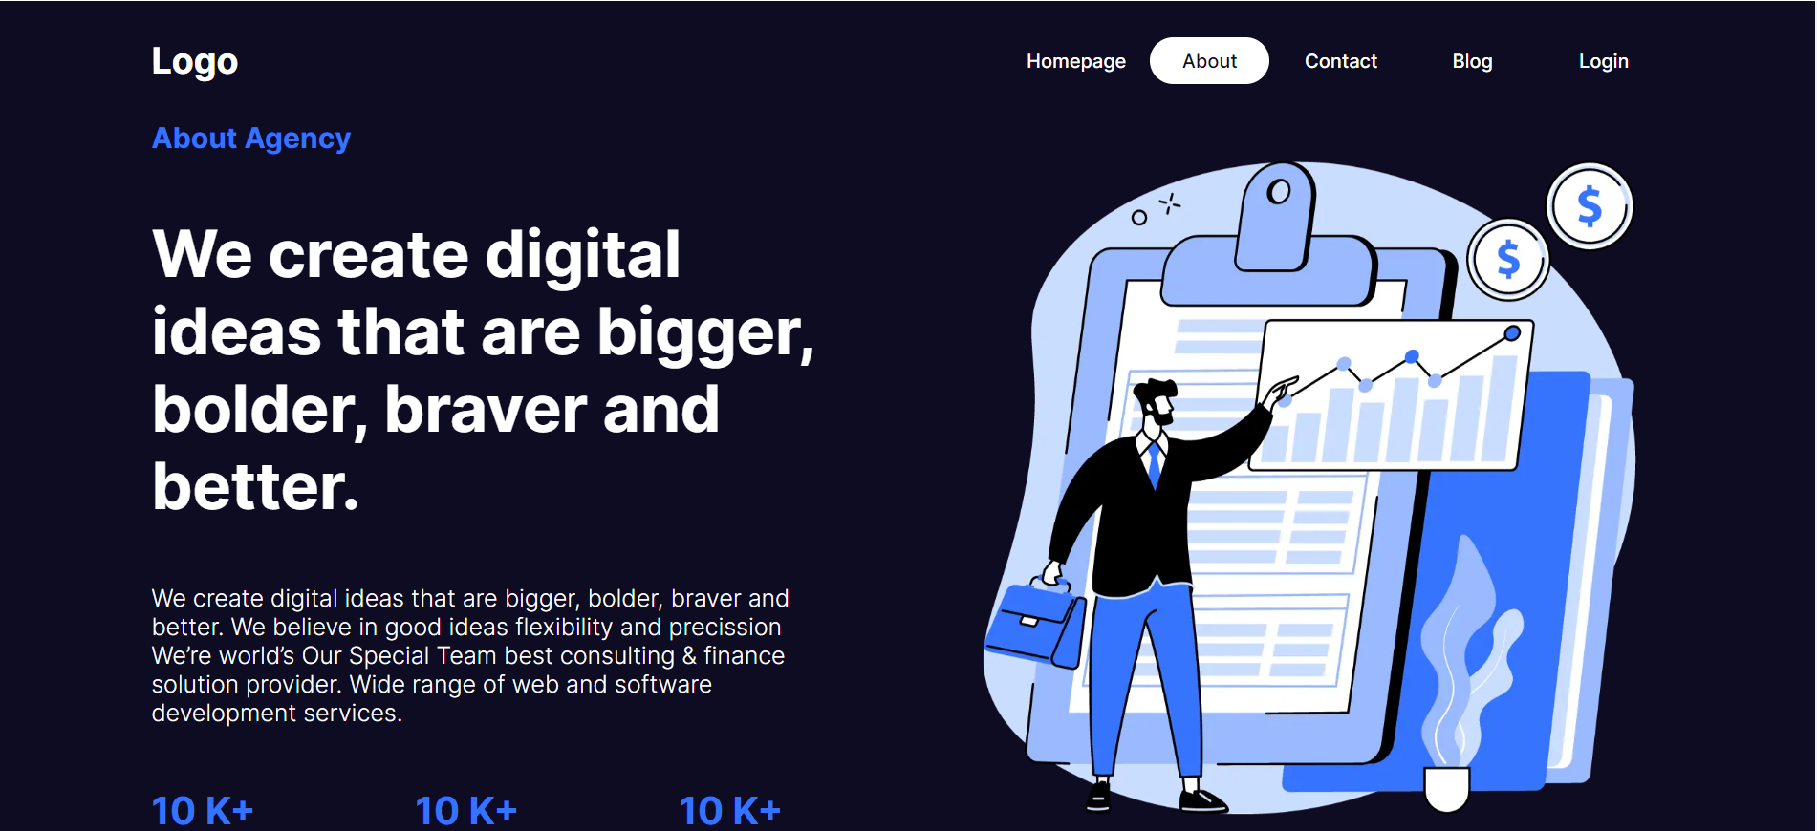

3 Contact Page

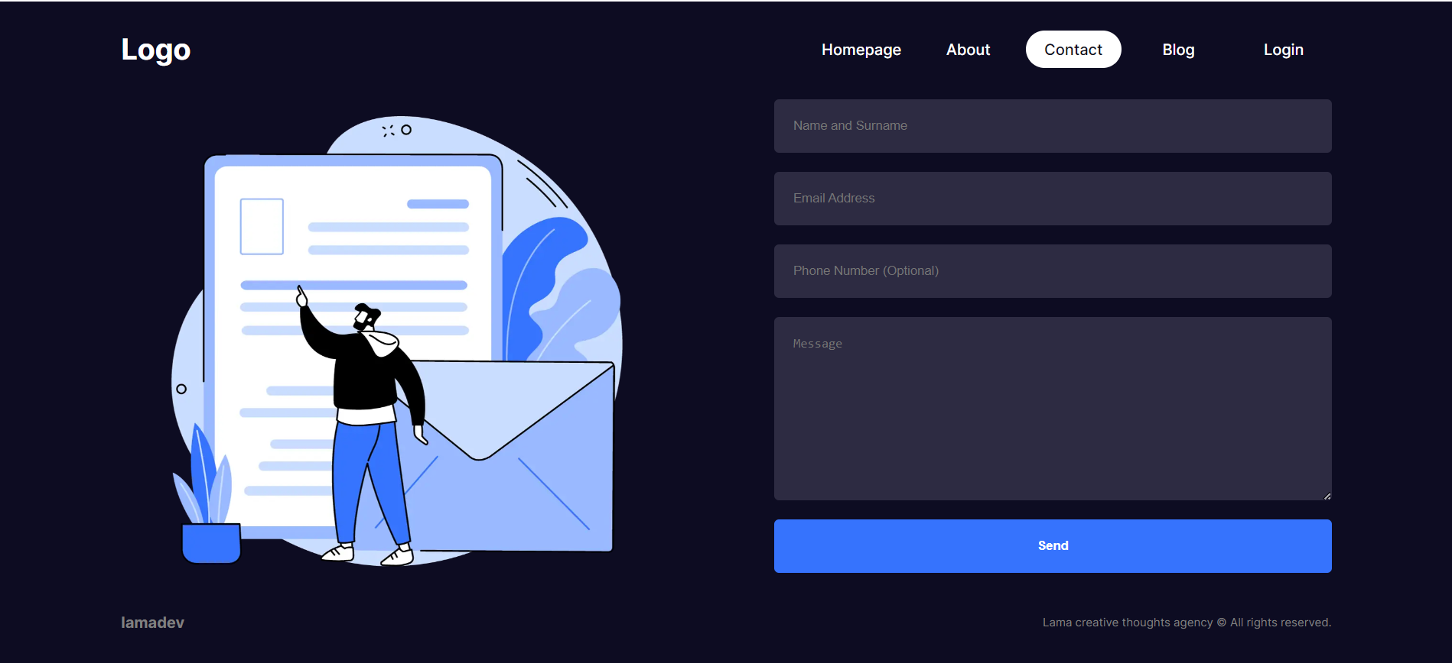

4 Login Page

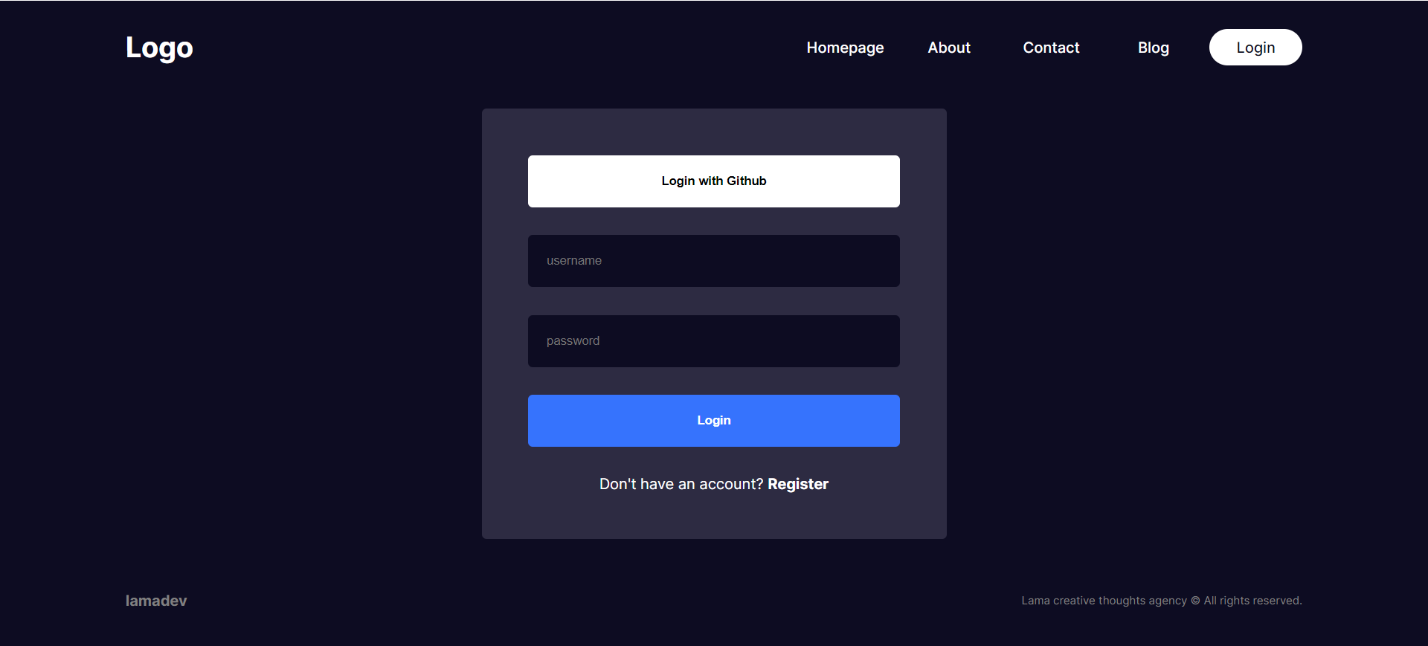

5 Register Page

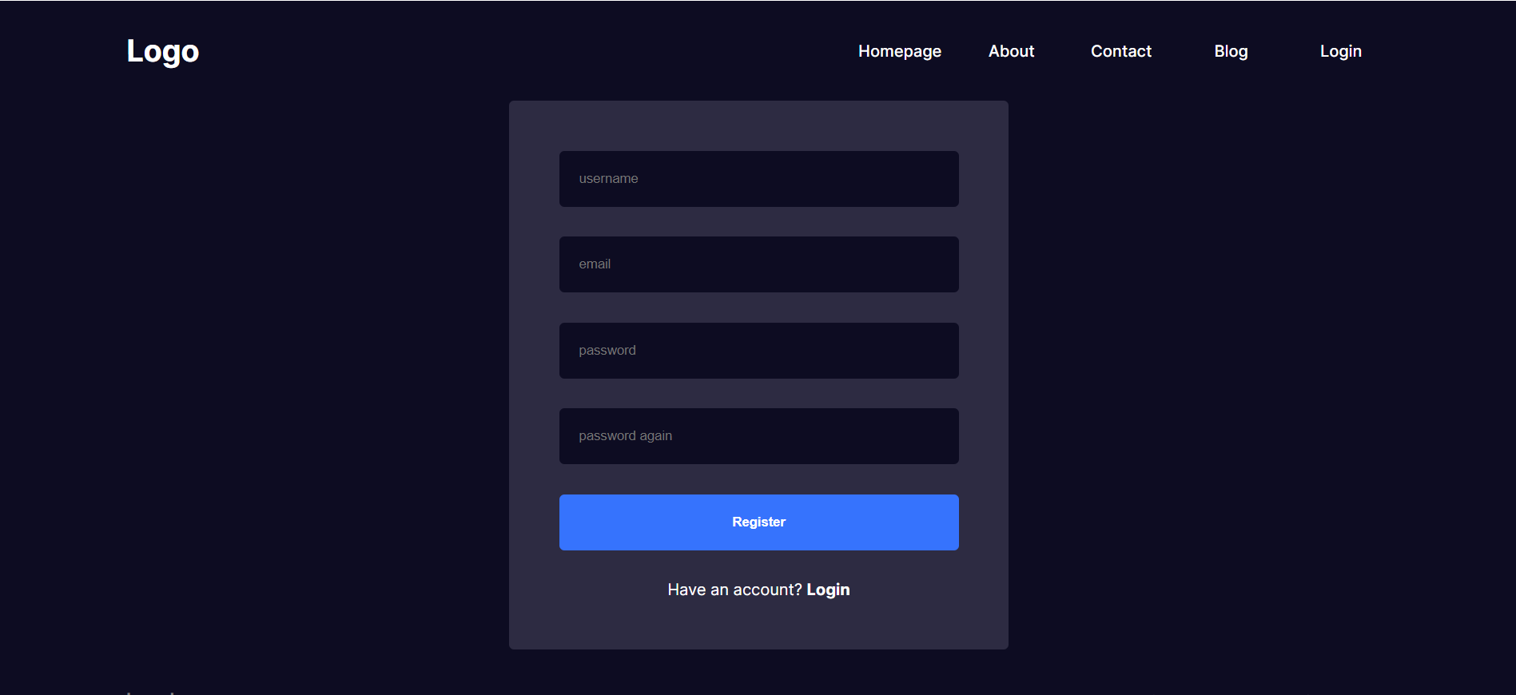

6 Admin Page

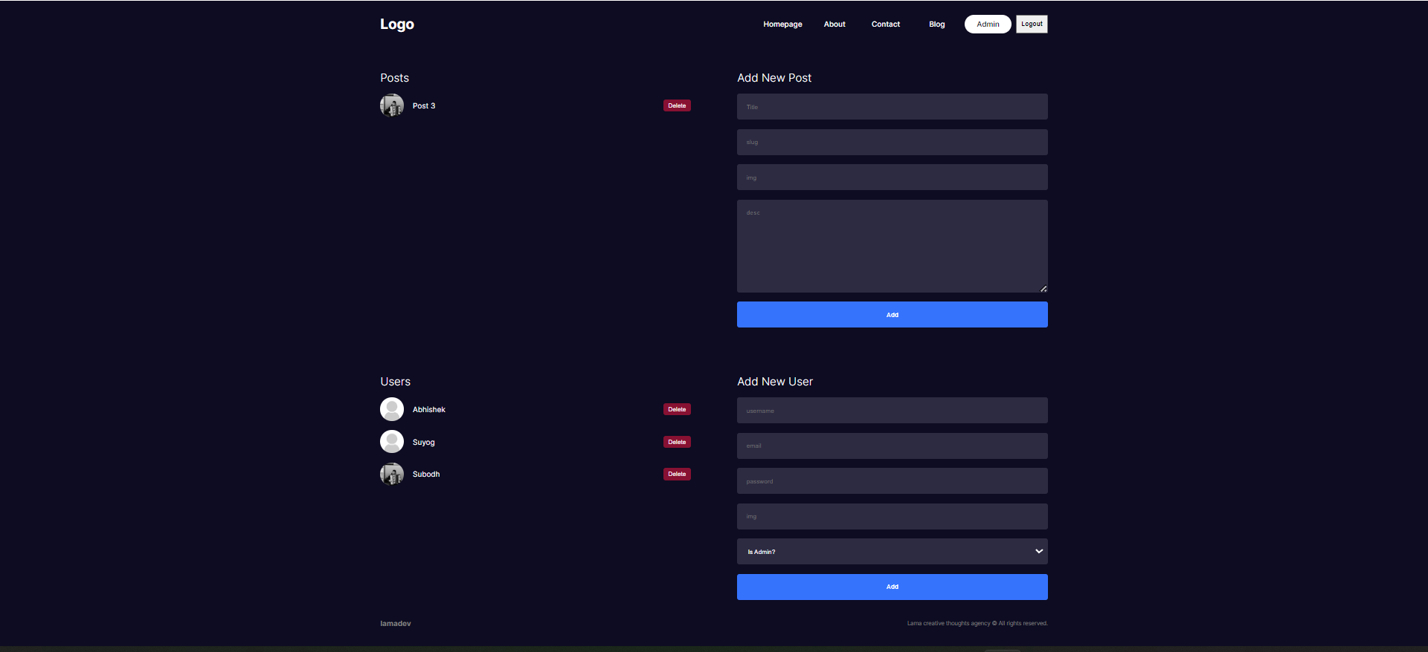

7 Blog Page

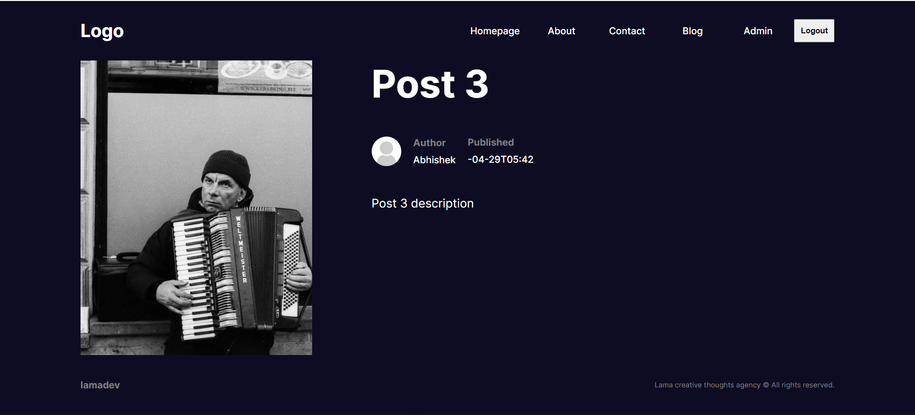

6.1 Conclusion
In conclusion, the NextTale project stands as a testament to the transformative potential of technology in shaping the landscape of digital storytelling and content dissemination. Through the seamless integration of Next.js, React.js, and MongoDB, NextTale has successfully realized its vision of providing a dynamic platform where individuals can create, share, and engage with compelling narratives.
The journey of NextTale underscores the importance of user-centric design, technological innovation, and community engagement in the development of online platforms. By prioritizing intuitive user interfaces, robust backend infrastructure, and inclusive features, NextTale has cultivated a vibrant ecosystem where creativity flourishes and voices are amplified.Looking ahead, the future of NextTale holds immense promise for further growth, evolution, and impact. As the platform continues to iterate and expand, it has the potential to redefine the way we conceive of digital publishing, knowledge sharing, and online community building.
In essence, NextTale is not merely a blogging website; it is a catalyst for inspiration, connection, and empowerment in the digital age. As users continue to write, read, and engage with content on NextTale, they contribute to a rich tapestry of stories that transcend boundaries and enrich lives.
In conclusion, the NextTale project serves as a testament to the power of technology to democratize storytelling, foster dialogue, and empower individuals to share their voices with the world. With its successful launch, NextTale embarks on a journey of endless possibilities, shaping the future of digital content creation and consumption for generations to come.

6.2 Future Work:

As NextTale embarks on its journey beyond the initial development phase, several avenues for future work present themselves, promising to enhance the platform's functionality, user experience, and reach:

1. Feature Expansion: NextTale can explore the integration of additional features such as multimedia content support (videos, podcasts), real-time collaboration tools for co-authored posts, and advanced search functionalities to improve content discoverability and engagement.

2. Enhanced Personalization : Implementing machine learning algorithms for personalized content recommendations based on user preferences, browsing history, and engagement patterns can significantly enhance user satisfaction and retention.

3. Monetization Strategies : NextTale can further develop and refine its monetization strategies by exploring options such as sponsored content partnerships, affiliate marketing programs, and premium subscription tiers, thereby diversifying revenue streams and ensuring long-term sustainability.

4. Community Building: Facilitating community engagement through features like discussion forums, commenting systems, and user-generated content challenges can foster a sense of belonging and camaraderie among NextTale users, driving increased participation and retention.

5. Accessibility and Inclusivity: Prioritizing accessibility features such as text-to-speech functionality, alternative text descriptions for multimedia content, and customizable user interfaces can ensure that NextTale remains inclusive and accessible to users with diverse needs and preferences.

6. Internationalization and Localization: Expanding NextTale's reach by offering multilingual support, localized content, and culturally relevant features can cater to a global audience and foster a more inclusive and diverse community of creators and readers.

7. Performance Optimization: Continuously optimizing NextTale's performance through techniques such as codebase refactoring, server-side rendering optimizations, and image compression can ensure fast load times, smooth user interactions, and scalability as the platform grows.

By prioritizing these areas for future work, NextTale can continue to evolve and innovate, cementing its position as a leading platform for digital storytelling, community engagement, and knowledge sharing in the ever-expanding landscape of online publishing.

